Application questions
Applying this message to everyday life

- Why do you think you hear stories about how God is moving powerfully in RESTRICTED nations and not here where we have the freedom to worship? Is it easier to live out your faith in free America or in a RESTRICTED nation? Why or why not?

- What are some risks you have to face today to share your faith? Are you willing to take those risks?

- If you died today would you have have any regrets on how you lived your life for Jesus according to Romans 1:16? Why don’t you make a commitment now to not have those regrets and live life unashamed for Christ.

- 2 sides to Prayer… the persecuted church prays that our freedom would not be our downfall and they ask that we pray that they can endure under persecution, and not that it would stop.

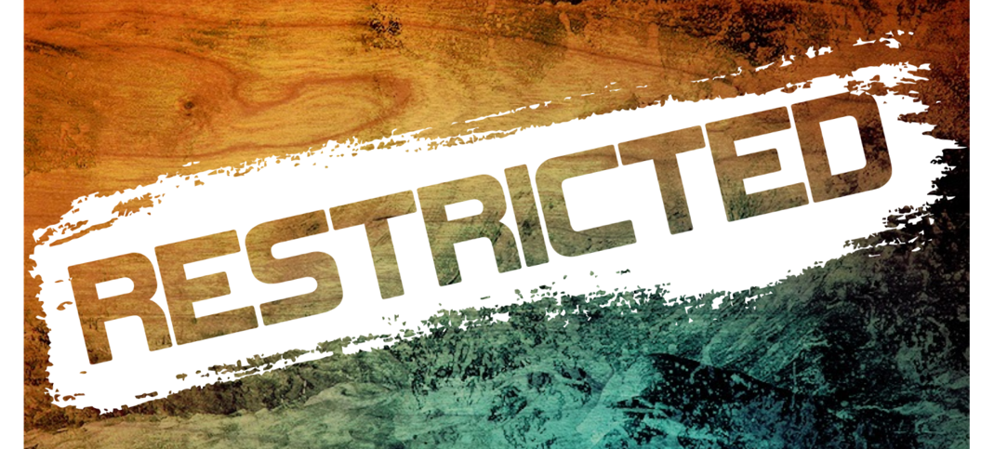
Acts 20:24

RESTRICTED:
Taking the Gospel to places where church activities and open evangelism is unlawful by the government and there is a serious threat to one’s life and fear of reprisal.
For the people who live in these nations there is no freedom of religion and there is no opportunity to hear the story of the Good News unless followers of Christ go. RESTRICTED is our term, not God’s. To Him no nation is closed. There is no wall or culture or religious system or police force that will keep out the life-changing power of the Holy Spirit!
(Romans 10:14-15)
GLOBAL IMPACT... (answers in GLOBAL IMPACT brochure)
What are the 3 elements of our GLOBAL IMPACT Strategy? __________________, __________________, __________________
Connect our GLOBAL PARTNERS to the area that they are serving.
Mitch Anderson Horn of Africa
Dave Owen Micronesia Islands
Bryan Sexauer Africa/Mdl East/Indo-China
Oscar James India
Aychi Beyene Chile
John Stark West Africa
Getting-To-Know-Me Questions
Sharing time to get your group started

- If you could travel anywhere in the world where would you want to go? Why?

- Where was your most memorable short term mission trip? Why?

- Are there any fears or concerns that you have that keep you from partipating on a short term mission trip? Why or why not?

LIFE GROUP HOMEWORK
Jot down a brief answer to the following questions

Quick Review
- As you reflect on our GLOBAL PARTNER’S sermon last week, what one principle or insight stands out as being particularly helpful, insightful or difficult to grasp?

- India currently ranks #2 in world population with 1,343,839,984 people and steadily climbing. That is almost 18% of the total world poplution. In the next few years they will become #1. The U.S. is #3 with only 324,459,463. That is more than 1 billion less than India. What is the population of Punjab where Bryan Sexauer and Ignite the Nations concentrate their ministry? What are some potential challenges that they may face?

- There are 233 countries in the world and over 7100 languages. Some are in danger of dying out, other languages are being newly formed. 23 large languages account for more than half of the world’s population. 2/3 of the world’s languages are from Africa and Asia. Over 2,400 projects are active worldwide working to get stories from the Bible those languages. Roughly 3,200 of the world’s languages have some selections and stories from the Bible, although much of the material is very old or unavailable at the local level. In addition, there are approximately 1,500 languages with no access to the the Bible’s presentation of the Good News of Jesus Christ and His love for them. These numbers point out a strategic need for Bible translation work of some nature in over 4,700 languages. What is John Stark’s mission and how many countries and languages is he involved with? What is the 10/40 Window a reference to? What is the difference between Bible translation and orality? What factors in a situation would make Oral Bible Storying an appropriate element in a mission strategy?

- Earth is home to untold millions of islands. Finland alone has about 300,000 islands. In the end, we can’t count them all, there are too many. One in every ten people on Earth is an islander and more than 600 million people live on islands. Which of our Global Partners concentates their ministry in the islands? What challenges would our GLOBAL PARTNER face when it comes to the islands?

